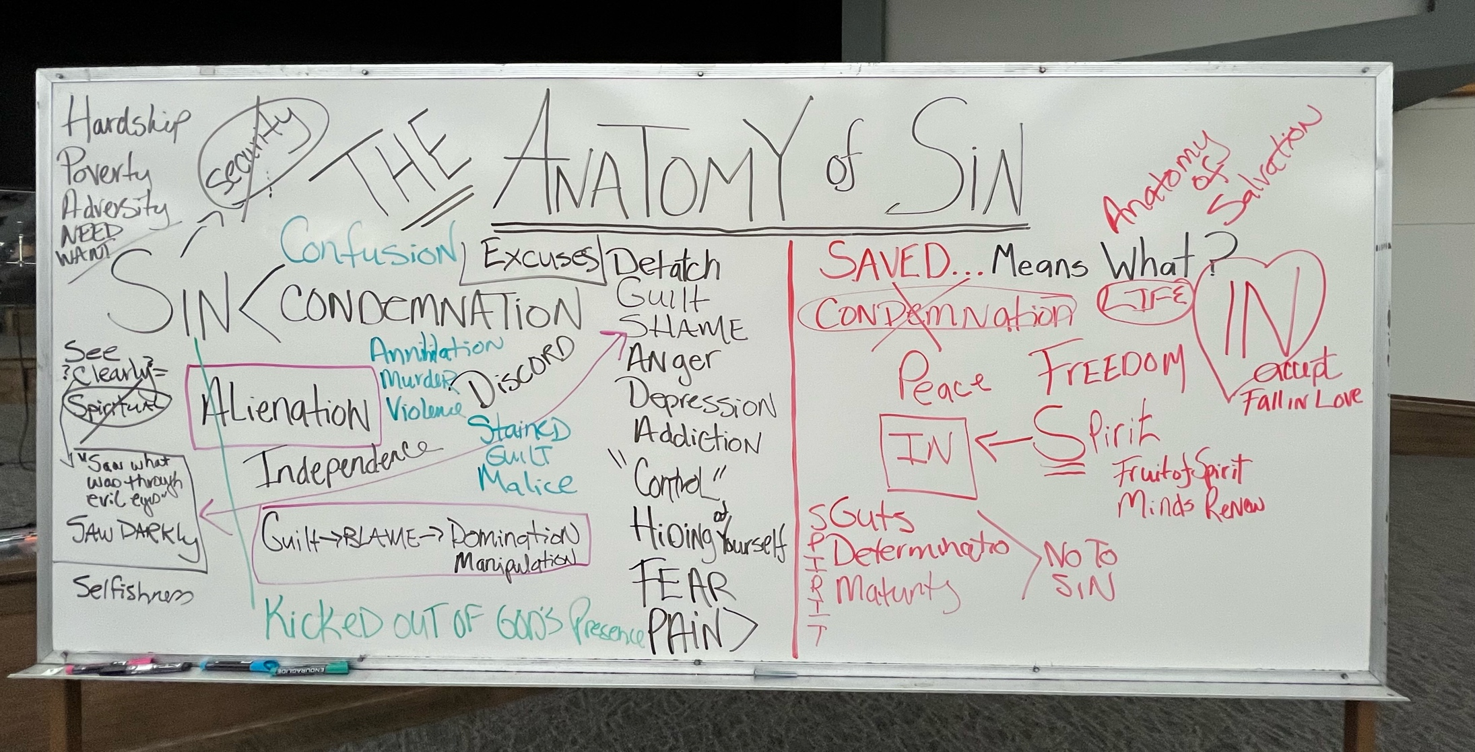

Genesis 3:7-24
Isaiah 59:1-21
James 1:5 Once those cravings conceive, they give birth to sin; and when sin grows up, it gives birth to death.

Romans 8:1-17
Galatians 6:8 Those who plant only for their own benefit will
harvest devastation from their selfishness, but those who plant
for the benefit of the Spirit will harvest eternal life from the Spirit.

